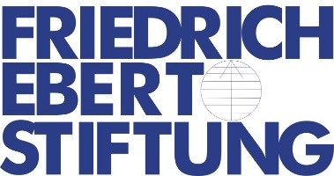
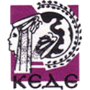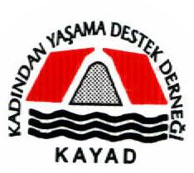
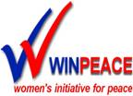

WINPEACE- CYPRUS, GREECE, AND TURKEY
ANNUAL CAMP FOR A CULTURE OF PEACE AND NON VIOLENCE
HRAKLEION CRETE 22 JULY – 29 JULY 2017

APPLICATION FORM FOR PARTICIPANTS

Please return the application form by JUNE 15, 2017 to mariat@ucy.ac.cy

Your Email: ………………………………………………………………………………..

Personal Information
Family and first names
Home Address (Including Zip Code )
Telephone Number of Participant:  Parents: | Home: Mobile:  Parents’Mobile:
E-mail
Nationality
Date and Place of Birth
You are : | Male Female
School you atten

d
Please state any medical or physical problems you have and any medication you need
Special Dietary Needs:
Contact person in case of emergency | Name: Tel:

Please note: The declaration below will provide the organizers with further info about the applicants.
Activities / Personal Interests
Your level of English: | Poor Medium Good Fluent  Good in Listening/Reading, but hesitant in Speaking
Why do you want to participate in the Youth Peace education Camp? (max. 300 words)

Parents’ or Guardians Signature | As parent / guardian of the above applicant, I have read and agree to the purpose of the Youth Peace education Camp and I consent to my child participating in the activities (during and after the camp) mentioned therein.
Signature of the Applicant:
Date and Place:

